

American International University-Bangladesh (AIUB)

**Department of Computer Science**

**Faculty of Science & Technology (FST)**

**FALL 22 23**

[**Lawyer Connect: Find Your Legal Expert**](https://sumitchakraborty218.atlassian.net/browse/LCFYLE)

Software Requirement Engineering

Sec: **E**

**Project submitted by:**

*MD. BENJIR HASAN (20-43494-1)*

*SHANTO KUMAR BASAK (20-42945-1)*

*UDAY KUMAR SARKER (20-42941-1)*

*SALIMA FARAH (20-42497-1)*

# Checked By Industry Personnel

Name: Debashish Basak

Designation: Project Manager

Company: ILFSL

Sign:

Date: 01/08/2023

# PROBLEM DOMAIN

## Background to the Problem

## In Bangladesh, locating a competent and trustworthy attorney tailored to specific requirements proves to be a formidable task. Situations like property disputes, accident claims, taxation concerns, and more pose significant challenges. This is particularly true for individuals lacking personal affiliations within the legal realm. A common approach involves seeking advice from acquaintances or scouring online resources and directories. However, this approach consumes considerable time and financial resources, with no assurance of securing a fitting legal representative. Moreover, accessing legal aid remains an arduous undertaking for those residing below the poverty threshold, leaving them vulnerable to adverse situations.

## Root Cause:

The primary challenge lies in the absence of a dependable and streamlined mechanism through which individuals can conveniently discover and schedule consultations with lawyers in Bangladesh. This concern significantly impacts both individual citizens and businesses throughout the nation. The underlying source of this issue can be traced to the absence of a comprehensive and centralized repository containing information about lawyers and their specialized domains. Consequently, establishing connections with lawyers becomes an intricate endeavor. Moreover, locating details regarding lawyer availability and arranging appointments poses considerable difficulty. As a consequence, individuals frequently depend on referrals, expending substantial time, energy, and financial resources to address their legal requirements.

## Importance:

Facilitating the establishment of a user-friendly platform for locating and reserving appointments with lawyers in Bangladesh holds significant importance. Firstly, such a system would enhance individuals' accessibility to justice by simplifying the identification of proficient legal practitioners. This, in turn, can elevate the overall efficacy of Bangladesh's justice framework and foster the advancement of its legal infrastructure. Moreover, it would serve to safeguard the legal rights of the populace. Secondly, the platform would extend valuable legal services to medium and small-scale enterprises that might need more means to engage prominent law firms. Thirdly, the platform's cost-effective nature could benefit underprivileged individuals, providing them with accessible legal support. Ultimately, this initiative harbors the potential to stimulate innovation and digital transformation within Bangladesh's legal sector, consequently catalyzing industry growth.

## Solution to the Problem

To tackle the challenge of identifying and reserving appointments with lawyers in Bangladesh, our suggestion involves creating a digital platform, whether through a website or an application, incorporating the following functionalities:

1. A comprehensive registry of verified lawyers showcasing their expertise across diverse legal domains, qualifications, and client reviews.
2. A search tool enabling users to pinpoint lawyers based on their legal requirements, geographical proximity, availability, and other pertinent criteria.
3. An appointment booking mechanism empowering users to directly schedule consultations with lawyers via the platform, offering the choice of online or in-person meetings.
4. An intuitive interface ensures effortless navigation and utilization for clients.

This proposed solution is exceptionally well-suited to the predicament, as it establishes a centralized and efficient means for identifying and reserving interactions with lawyers across Bangladesh. The platform streamlines the process by eliminating the need for telephonic conversations or physical visits to law firms, conserving users' time and effort. Additionally, it broadens access to a diverse pool of lawyers with varying expertise, ensuring optimal counsel selection for distinct legal requirements.

From a business perspective, the suggested solution aligns harmoniously with the company's vision of crafting innovative software solutions that augment user experiences. The platform's revenue generation would stem from booking fees and advertising, rendering it a viable and prosperous venture.

## Software Description:

The initiative involves the development of a web or app-based system designed to streamline the process of discovering and reserving lawyer appointments in Bangladesh. This platform will offer users access to a repository of accredited lawyers proficient in various legal domains. Furthermore, it will present client feedback, ratings, and reviews for enhanced decision-making.

Users can identify suitable lawyers based on their distinct legal prerequisites, geographic location, availability, and other pertinent attributes. The platform will also facilitate the direct scheduling of appointments with lawyers, thus circumventing the necessity for telephonic correspondence or physical visits to legal establishments.

The software's principal objectives encompass enhancing access to justice by simplifying the identification of capable and reliable legal professionals. It also seeks to provide a valuable service to businesses, notably small and medium-sized enterprises, while propelling innovation and digital advancement within Bangladesh's legal sector."

## Existing Studies:

In Bangladesh, many online directories and websites exist, furnishing details about lawyers and legal firms. Nevertheless, these resources frequently need to be updated, rendering it arduous for users to access dependable information. Additionally, certain legal tech enterprises in Bangladesh offer online legal services, but their focus often revolves around specific legal realms such as contract drafting or dispute resolution. As a result, they need a comprehensive solution for identifying and reserving appointments with lawyers.

The proposed solution represents an innovative and original approach to locating and scheduling lawyer appointments in Bangladesh. Its potential to substantially influence the country's legal sector is noteworthy."

# SOLUTION DESCRIPTION

## System Features:

## System Features:

## Lawyer Database:

* **Functional Requirements:**
* Compile lawyer profiles containing their qualifications and areas of legal proficiency.
* Provide lawyers with the capability to keep their profiles current by updating their information and indicating their availability.
* Empower users to search for lawyers based on their specific legal requirements, geographical location, availability, and other pertinent parameters.
* Exhibit feedback and ratings from previous clients, showcasing reviews of lawyers' past performance.

## Quality Attributes:

* Ensuring accuracy and comprehensiveness of data.
* Enhancing search efficiency and precision.
* Providing an interface that is user-friendly and intuitive.
* Safeguarding the privacy and security of both lawyer and client information.

## Appointment Booking System:

* **Functional requirements:**
* Enable users to arrange appointments directly within the platform.
* Offer choices for consultations, either online or in-person.
* Dispatch appointment confirmations and reminders to both users and lawyers.
* Permit users and lawyers to modify or cancel appointments as needed.
* **Quality attributes:**
* Assurance of the booking system's dependability and accessibility.
* Interface designed for user-friendliness and intuitive interaction.
* Effective communication facilitation between users and lawyers.
* Precision and punctuality of notifications.

## User Management:

* **Functional requirement:**
* Enable users to establish and oversee their profiles.
* Offer user authentication and permission management.
* Allow users to access their appointment history along with ratings and reviews.
* **Quality attributes:**
* Preservation of user data security and privacy.
* An interface that is user-friendly and intuitive.
* Effective communication streamlining between users and lawyers.
* Precision and punctuality of notifications.

## Lawyer Management:

* **Functional management:**
* Enable attorneys to establish and oversee their profiles.
* Offer lawyer authentication and permission management.
* Allow lawyers to access their appointment history along with ratings and reviews.
* **Quality attributes:**
* Assurance of confidentiality and privacy for lawyer data.
* An interface that is user-friendly and intuitive.
* Effective communication streamlining between users and lawyers.
* Precision and punctuality of notifications.

## Payment System:

* **Functional Requirements:**
* Enable users to perform payment transactions for their scheduled appointments.
* Ensure a robust and secure system for processing and handling payments.
* Automatically generate invoices and receipts for both users and legal professionals.
* **Quality Attributes:**
* Prioritize the utmost security and precision in the payment processing procedures.
* Design an intuitive and user-friendly interface that enhances user experience.
* Implement a payment processing system that is both efficient and dependable.
* Guarantee accurate and timely notifications for all relevant interactions.

## Search Engine Optimization (SEO):

* **Functional Requirements:**
* Enhance the website/app's compatibility with search engines.
* Conduct research to identify pertinent keywords that will enhance search result rankings.
* Incorporate meta tags and descriptions for individual lawyer profiles.
* **Quality Attributes:**
* Enhance the platform's visibility and ease of discovery.
* Boost traffic and user interaction on the website/app.
* Elevate the platform's standing in search engine rankings.
* Employ SEO techniques with efficiency and effectiveness in mind.

## Notification System:

* **Functional Requirements:**
* Enable the automated dispatch of notifications to both users and lawyers via the portal, encompassing appointment confirmations, reminders, cancellations, and rescheduling.
* **Quality Attributes:**
* Ensure the precision and punctuality of notifications.
* Design an interface that is user-friendly and intuitive.
* Establish a system for efficient and dependable delivery of notifications.
* Provide the option for users to personalize their notification preferences.

## Feedback System:

* **Functional Requirements:**
* Provide users with the ability to submit feedback and assign ratings to lawyers after their appointments.
* Present lawyer ratings and reviews prominently on their profiles.
* Enable lawyers to respond to feedback and ratings they receive.
* **Quality Attributes:**
* Design an interface that is both user-friendly and intuitive.
* Establish a streamlined and productive process for collecting and overseeing feedback.
* Ensure the precise presentation of lawyer ratings and reviews.
* Foster a feedback environment that is constructive and respectful.

## Reporting:

* **Functional Requirements:**
* Gather and assess data related to the usage of the platform.
* Produce comprehensive reports regarding user and lawyer engagement, appointment records, and generated revenue.
* **Quality Attributes:**
* Ensure the accuracy and comprehensiveness of collected data.
* Implement an efficient and proficient process for acquiring and analyzing data.
* Design a reporting interface that is user-friendly and intuitive.
* Provide data insights that are timely and pertinent to the context.

## Integration with External Services:

* **Functional Requirements:**
* Establish integration between the platform and external services, including online payment gateways and third-party scheduling software.
* Enable users to initiate payments using their chosen payment gateway.
* **Quality Attributes:**
* Ensure a smooth and coherent integration with external services.
* Provide a secure and trustworthy payment processing system.
* Implement an integration design that is efficient and productive.
* Design an external service integration interface that is user-friendly and intuitive.

## 2.1 UML Diagrams

**Use-case diagram:**

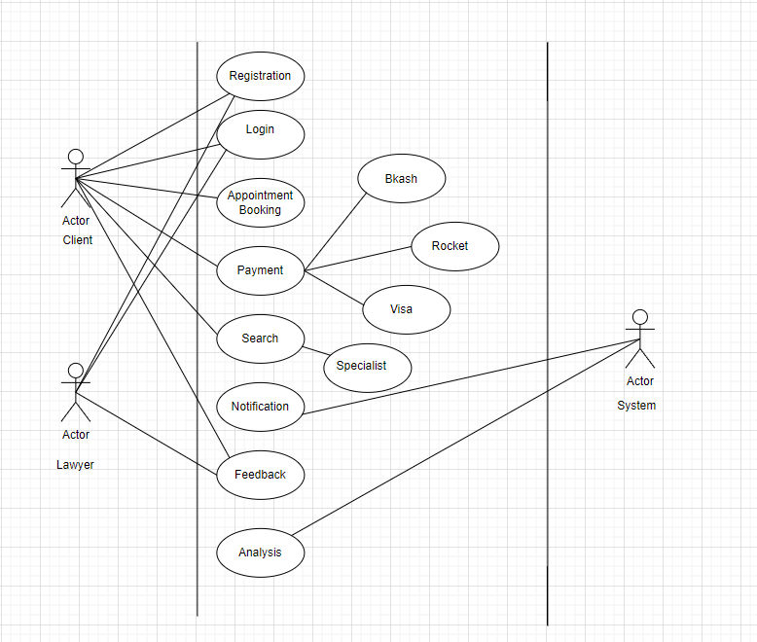

## Activity Diagram:

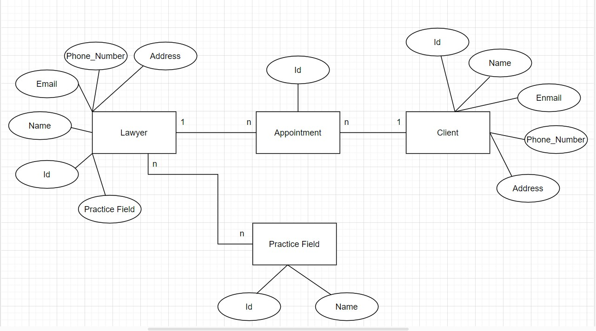**E-R diagram:**

# Social Impact

The suggested idea of developing a web or mobile application to facilitate the discovery and booking of appointments with lawyers in Bangladesh carries the potential to yield various societal benefits. For example, the application could make legal services more attainable for individuals who may have struggled to locate or afford legal representation. This could contribute to narrowing the gap in access to justice, guaranteeing that legal guidance is of our proposed idea should be available to everyone, irrespective of their financial status or geographical location.

Moreover, the platform can heighten the legal system's effectiveness by simplifying lawyer-client interactions and appointment management. This could lead to time and resource savings for lawyers who would otherwise invest efforts in sourcing new clients and managing their schedules. This optimization could result in reduced costs and elevated productivity.

Additionally, the platform allows users to provide feedback and ratings for the lawyers they engage with, which could foster transparency and accountability within the legal sector. This could play a crucial role in ensuring the delivery of high-quality legal services and building trust between legal professionals and their clients.

In summary, the proposed project holds the potential to enhance the accessibility of legal services, boost efficiency within the legal sector, and advocate for transparency and responsibility within the legal profession.

# Development Plan with Project Schedule Project Plan

**Initiate Project**

1. **Create Project Chart**
   * Outline Project Scope
   * Define Project Requirements
2. **Finalize Charter and Obtain Approvals**
   * Compile and Publish Project Charter
   * Conduct Review Meeting
   * Revise Project Charter
   * Secure Government Approvals
3. **Project Planning**
   * Develop Work Plan
   * Create Project Staffing Plan
   * Craft Project Schedule
   * Formulate Project Budget
4. **Formulate Project Control Strategy**

* Craft Communication Plan
* Establish Quality Management Plan

1. **Design Phase**

* Determine Stages and Tasks
* Design Content Formats
* Conduct Object Design Review

1. **Development Phase**

* Write Source Code
* Conduct Project Review with Legal Experts

1. **Testing Phase**

* Perform Unit Testing
* Conduct Usability Testing

1. **Implementation Stage**

* Transition Tool to Production Environment
* Declare Tool Availability

1. **Close Project**

# Project Schedule:

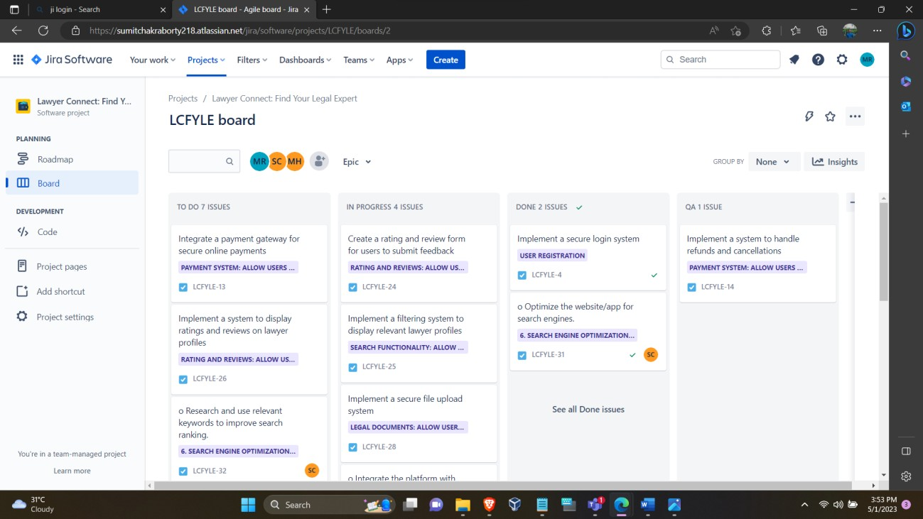

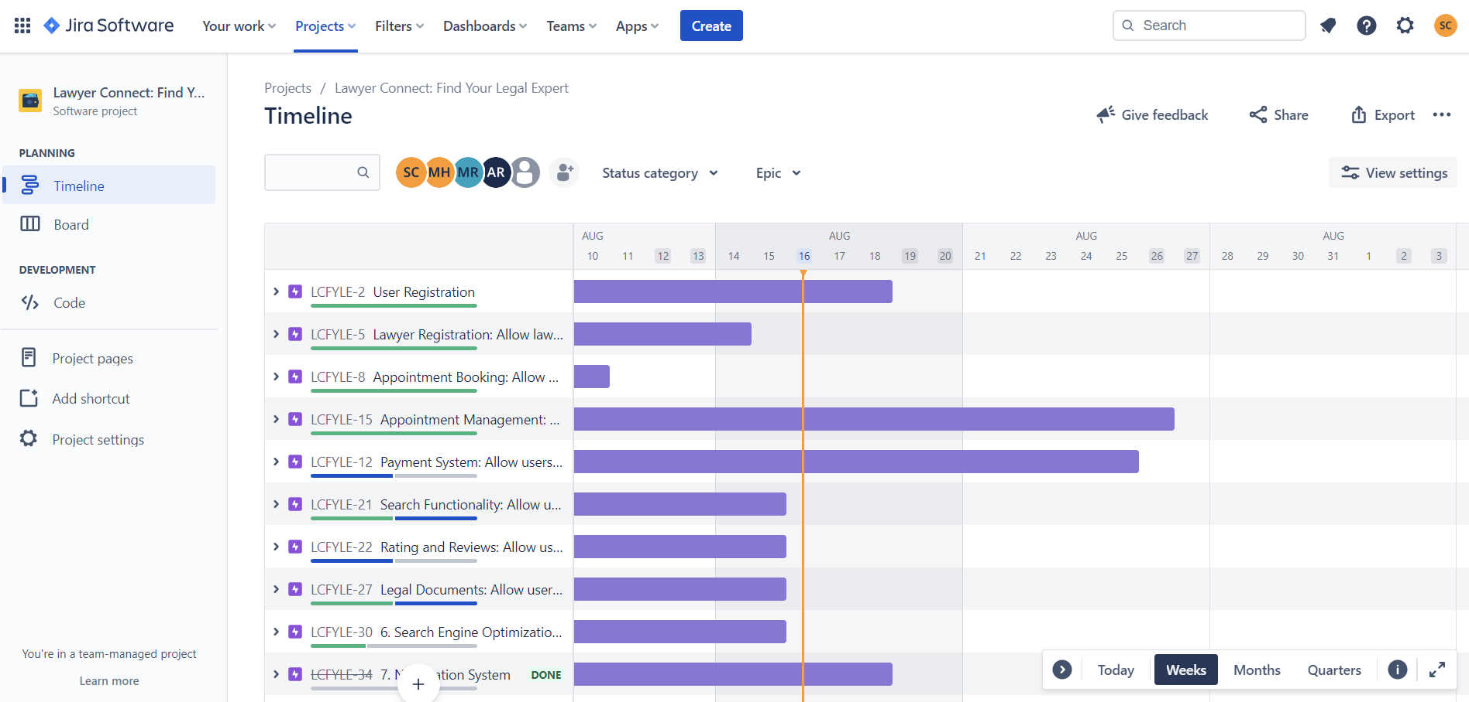

1. **Marketing Plan**

The envisioned web or mobile application designed to facilitate the discovery and arrangement of meetings with legal professionals in Bangladesh holds potential benefits for the legal sector and society on a broader scale. However, to ensure the platform's successful launch and widespread adoption, it is imperative to devise a comprehensive marketing strategy.

**Short-Term Strategy:**

* Increase brand recognition: Leverage social media channels like Facebook, Instagram, and Twitter to amplify platform visibility and bolster brand recognition.
* Offer introductory incentives: Provide initial discounts or complimentary consultations to entice new users and encourage their platform adoption.
* Cultivate strategic partnerships: Collaborate with law firms and legal associations to promote the platform among their clientele and members.

**Long-Term Approach:**

* Invest in Search Engine Optimization (SEO): Optimize platform content and website to increase search engine ranking and increase organic traffic.
* Execute paid advertising: Utilize targeted paid advertisements through platforms like Google Ads and different social media manifesto to reach a broader audience and channel traffic to the forum.
* Enhance platform capabilities: Continually innovate and integrate new features into the platform to enrich the user experience and attract fresh users.

**Continuous Initiatives:**

* Foster user engagement: Sustain active interaction with users through social media interactions, email newsletters, and informative blog content to provide updates, legal insights, and valuable resources.
* Introduce a referral initiative: Establish a referral program to motivate existing users to recommend new users to the platform.
* Solicit feedback and refine: Regularly collect user feedback to drive ongoing enhancements to the platform, thereby augmenting the user experience.

By implementing these immediate, enduring, and ongoing marketing strategies, the platform can gain momentum, attract novel users, and solidify its reputation as a dependable and efficient solution for locating and scheduling appointments with legal practitioners in Bangladesh.

# Cost and Profit Analysis

Development Cost:

Development team salaries: BDT 1,00,000 per month (for 6 months) = BDT 6,00,000 Server and hosting costs: BDT 50,000 per month (for 6 months) = BDT 3,00,000 Other development costs (e.g., software licenses, third-party APIs): BDT 1,50,000 Total development cost: BDT 10,50,000

Marketing Cost:

Social media advertising: BDT 10,000 per month

Search engine optimization (SEO) services: BDT 5,000 per month

Other marketing costs (e.g., events, partnerships): BDT 25,000 per month Total marketing cost: BDT 40,000 per month

Revenue:

Assuming an average appointment fee of BDT 500 and 1000 appointments per month, the monthly revenue would be:

BDT 500 x 1000 = BDT 5,00,000

Profit:

Total profit = Total revenue - Total cost

Total cost = Development cost + Marketing cost

Total cost = BDT 10,50,000 + (BDT 40,000 x 6) = BDT 12,90,000

Total revenue = BDT 5,00,000 x 6 = BDT 30,00,000

Total profit = BDT 30,00,000 - BDT 12,90,000 = BDT 17,10,000

Investment Return:

Assuming investors are interested in a 10% return on their investment, the amount of investment required would be:

Investment = Total cost / (1 - Investment return rate) Investment = BDT 12,90,000 / (1 - 0.1) = BDT 14,33,333.33

According to the profit assessment, the project anticipates yielding a profit amounting to BDT 17,10,000, a figure likely to capture the attention of prospective investors. The marketing strategy encompasses expenditures for social media advertising, SEO services, and various promotional expenses like events and partnerships. The developmental costs contain team remuneration, server and hosting prices, and other developmental outlays. Anticipated revenue will primarily stem from appointment charges, assuming an average fee ranging from BDT 500, with a projected monthly volume of 1000 appointments.

1. **Reference**
   * 1. <https://app.diagrams.net/>